

|  |  |  |  |  |  |  |  |  |
| --- | --- | --- | --- | --- | --- | --- | --- | --- |
|  | | | | | | | | |
|  | | CTF | | | | |  | |
|  |  | | | | | | |  |
|  | | | |  |  | | | |
|  | | | | TajkeyaSultana |  | | | |
|  | | | | 08/30/2023—Cybersecurity Capture the FlagLevel 1—Masterschool |  | | | |
|  | | |  | | |  | | |

## TABLE OF CONTENTS

Introduction …………………………………………………………………..3

Getting started………………………………………………………………..4

Linux Basics……………………………………………………………………5- 6

File system flags………………………………………………………………7-10

Webpage Flags…………………………….........................................10-15

Hash cracking…………………………………………………………………16-21

Nmap Scan……………………………………………………………………..21-26

Conclusion………………………………………………………………………27

Appendix…………………………………………………………………………28-30

|  |  |  |  |  |  |  |  |  |
| --- | --- | --- | --- | --- | --- | --- | --- | --- |
|  | |  |  | | |  |  | |
|  | | Introduction | | | | |  | |
|  | |  |  | | |  |  | |
|  | Synopsis Masterschool strives to challenge their students to think out of the box. This CTF challenge was created to test our ability to solve problems, test our technical skills, file management, navigation, prove the skills we acquired during Linux fundamentals and many more that would translate to the field of cybersecurity.  The assignment was straightforward, find the hidden flags using Linux commands or utilizing online resource. Being detailed and thinking outside the box was highly encouraged. | | | | | | |  |
|  | Challenges There were six challenges: | | |  |  | | |  |
|  | **Linux Basics:** demonstrate proficiency with basic Linux commands.  **File Flag System:** navigate and discover hidden flags through the file system.  **Webpage Flags:** navigate and discover hidden flags in webpages. | | |  | **Hidden Flags:** objectives hidden within a local system, webpage, or application, to be discovered utilizing learned skills.  **Hash cracking:** use appropriate tool to decrypt the hidden flags.  **Nmap Scan Report:** Run Nmap on the target to explore and discover open ports that can be exploited. | | |  |

**Lets’ Get Started**

The first step is to access the machine. After your machine has loaded and you can see root@IP, start entering “ssh ctf@your virtual machine IP address. It should look like the image below.

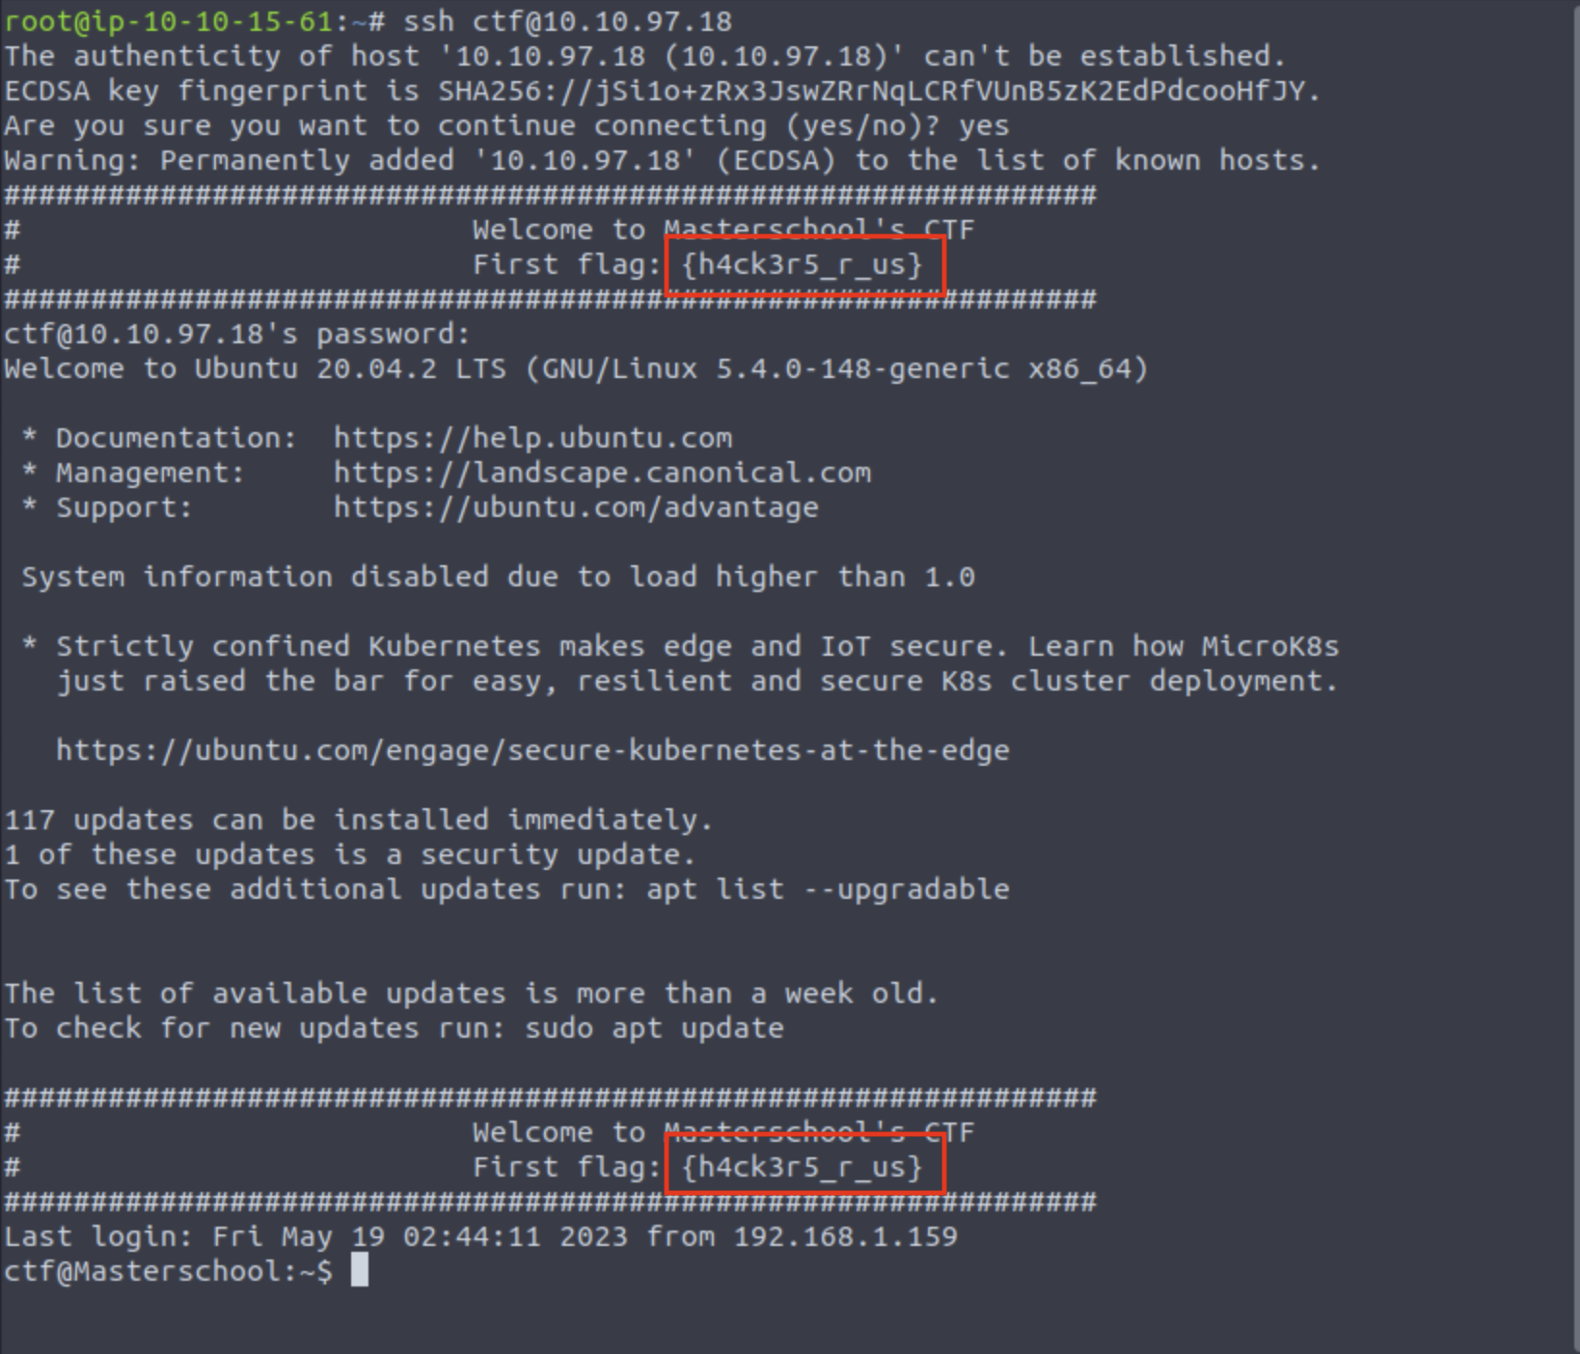

After we are in the system, we get our first flag.

**| {h4ck3r5_r_us}**

Now that we are in the system, we can start our challenge.

# Linux Basics: User and File Management

Our first challenge was to create a new user in the Linux system. To achieve this, we will be using “sudo” command. The sudo command allows us to run as an administrator, allowing us to make changes to users, create and delete users. Let just say it gives us premium privileges.

After we create our user, we have to assign it a password. For the next steps, press enter until you get the “Is this information correct? [Y/n]” type “y”. By pressing entering you are selecting the default option. For this process, we don’t have to enter all these information as shown in the image below.

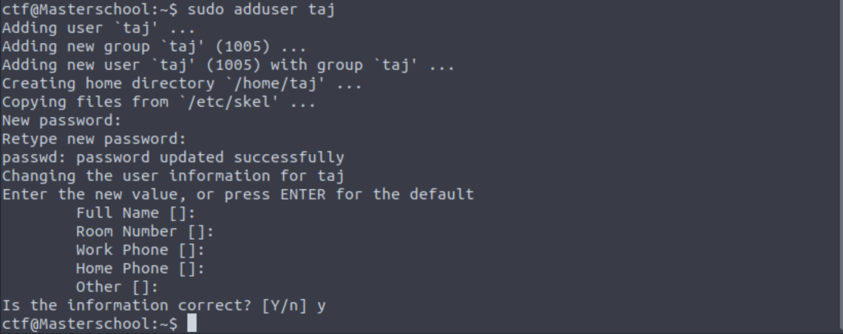

Next step is to use “su” to start user change process. “su” Allows us to switch between users. You will need to enter your password to access. Type in cd to switch user.

See image below.



Figure 3: Changing users

Now that we are in the user we want to be, its time to create folder and file. To create a folder, we will be using the “mkdir” command, which allows us create directories, a similar name is folder. This command can create multiple directories at once. It also allows the user to set permissions for the directories (folder).

The folder I created was “HiTaj”. I want to write a simple message inside the folder, let’s say “Hello World from Tajkeya”.

To create a message inside the directory, we need to use the “echo” command. It allows users to display lines of text or strings.

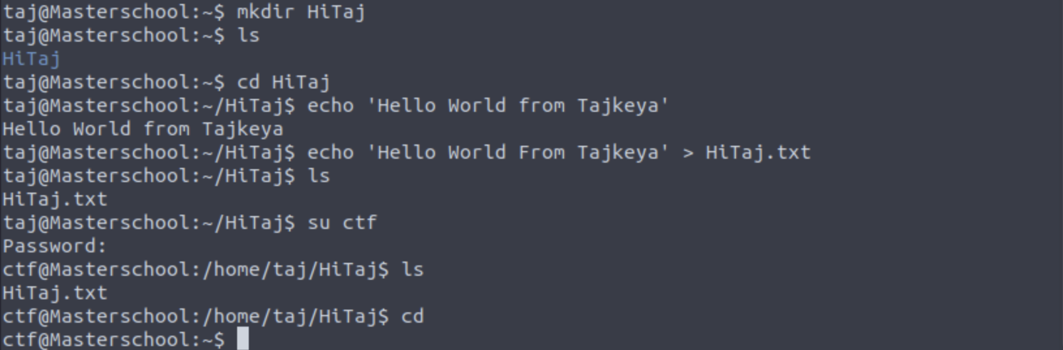

We created the text we want, now let’s save it using “>” and “HiTaj.txt” and change back to our default user which is CTF for this practice.

**First challenge done!!**

# File System Flag

This challenge had us navigating the file system to find the flags. The command “ls” came in handy as it gave us hints on where to start looking.

The first thing I did was type ls. The ls command lists all the files and directories. Typing in ls gave me “flag hash_to_crack”, so I knew this was one of the hidden flags. I than used “-a”. the command “ls -a” will list all hidden files beginning with a dot.

As you can see in the figure below.

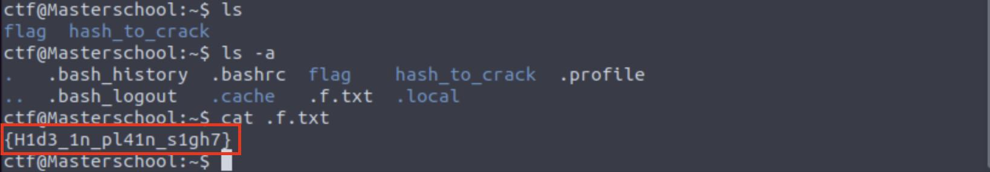

I used the cat command to display the flag directory. Which gave us our second hidden flag.

**| {H1d3_1n_pl41n_s1gh7}**

To find our next flag, we need to look for any files that end in “.txt”. We will be using the wildcard globing which represented by a asterisk, “**\***”. This lists all the file types in the current directories. Therefore, using “**\*.txt**” will display all the current directories that end in **.txt**.

The command we will execute is “*find . -name “*.txt*”. This command gave us another flag directory which is boxed in white.

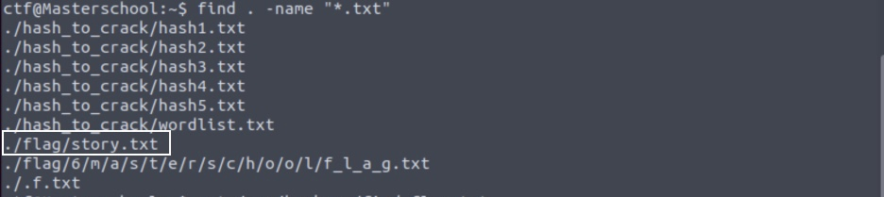

Figure 6: includes 2 flag directory commands.

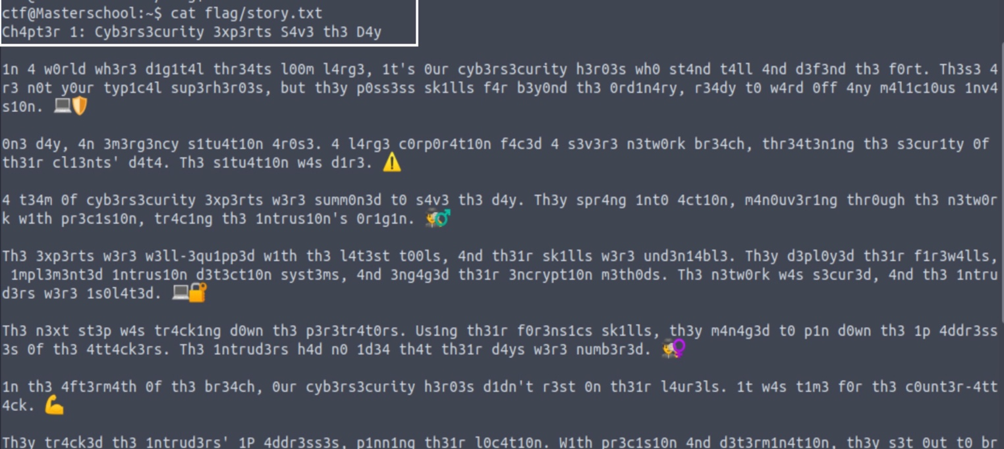

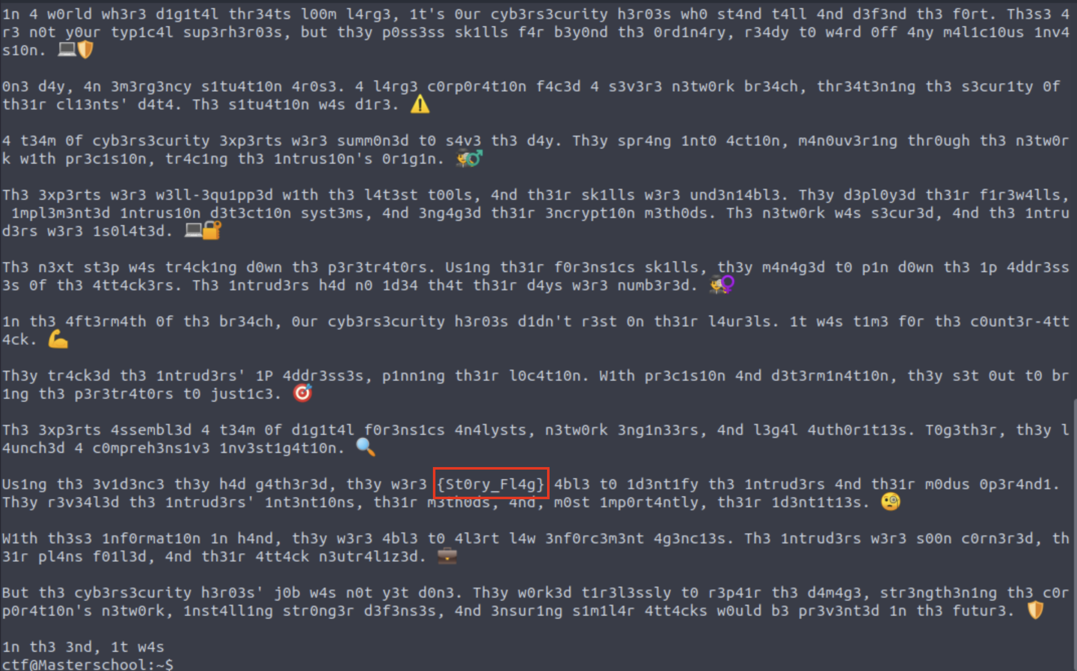

Our third flag was hidden in the story. I must say, I have never read a story like this before. It was quite enjoyable and a security story.

**| {St0ry_Fl4g}**

To find our next flag, he /var command which contains our variable data files came in handy. I had to seek aid from ChatGPT to find the correct command. We will still be using the “*.txt”, but adding a few more syntax.

After a few attempts, this is the command I decided to execute. “*find /var -type f -name “*.txt” 2>/dev/null*”. The “*2>/dev/null*” gets rid of the error messages providing us with only the necessary information we need.

After executing the command, we found our next flag directory which unveiled our fourth flag.

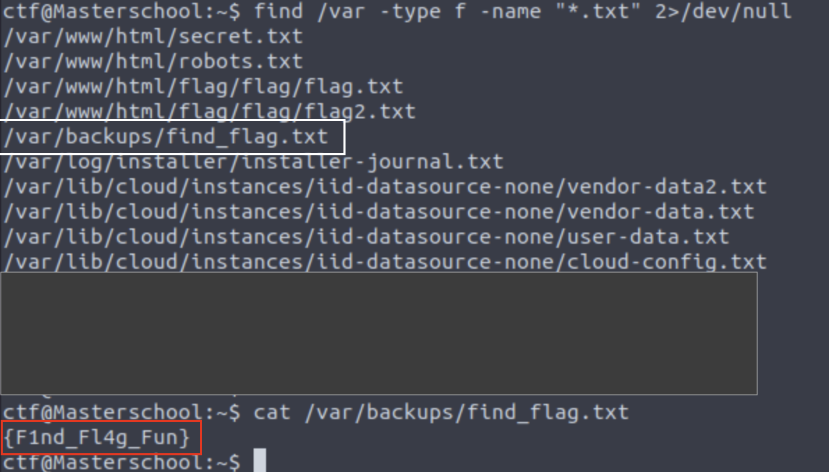

Fourth flag found.

**| {F1nd_Fl4g_Fun}**

For the last file flag, I had to cd to flag to unveil the hidden flag. If you recall figure 6, this flag directory was also there along with the ./flag/story.txt. This is another way of finding the flag directory.

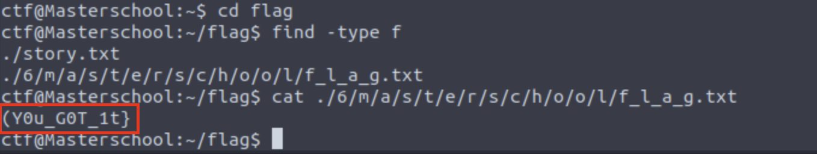

Fifth flag found.

**| {Y0u_G0t_1t}**

**Second challenge done!!**

# Webpage Flags & Hidden Flags

The webpage flags could have been found using Linux, but I wanted to try a different way. Let’s just say thinking outside the box. I utilized the web to find the next few flags.

The first thing I did was open the web and put in the machine IP address. Which displayed the sixth flag.

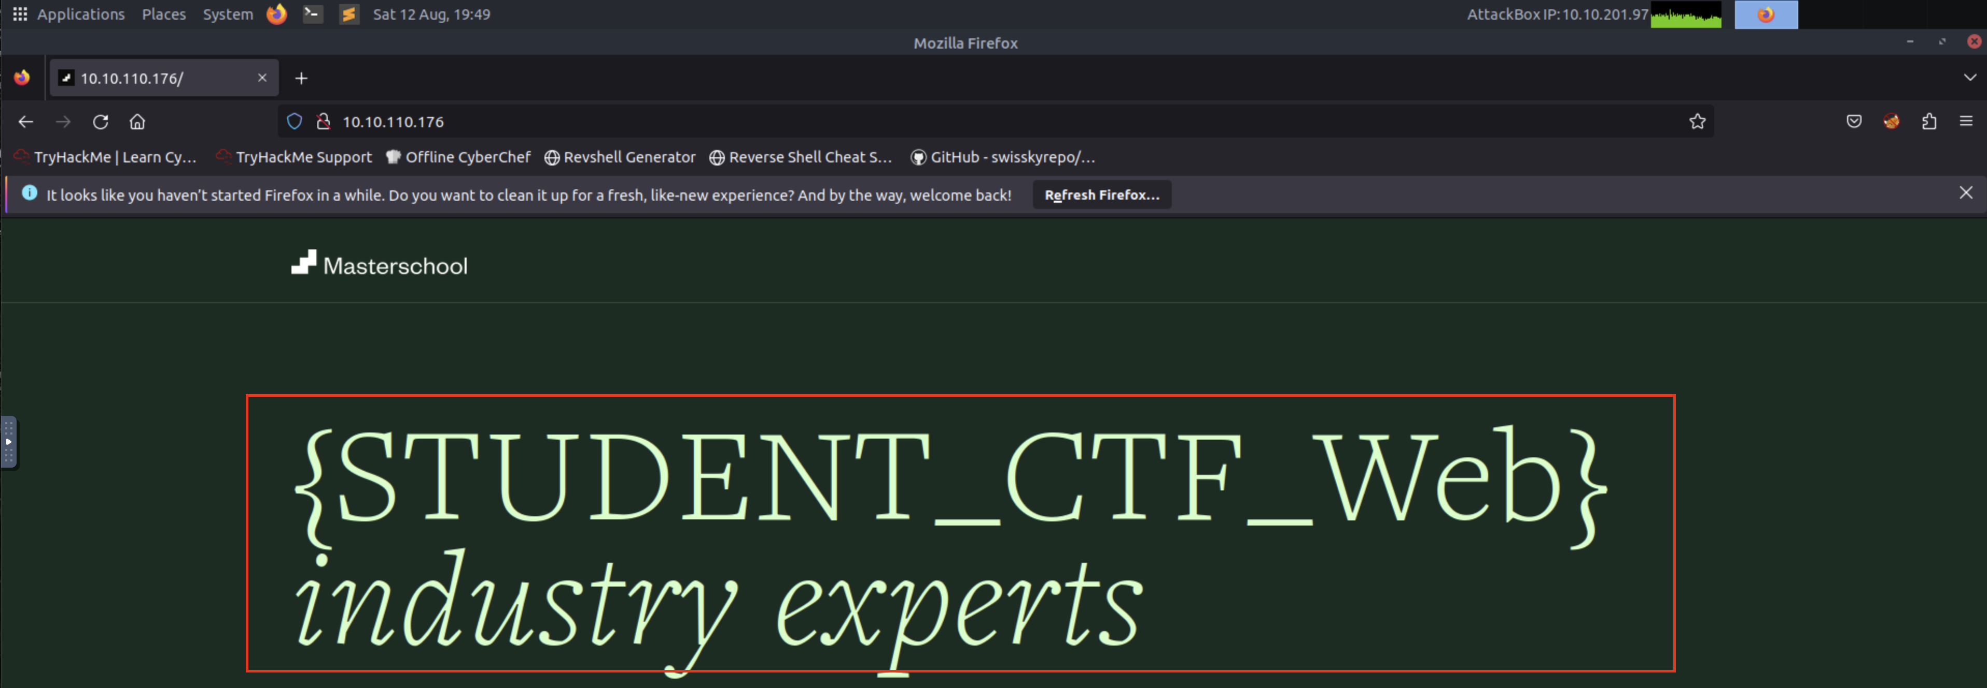

**| {STUDENT_CTF_WEB}**

For the next flag, I utilized http protocol and entered the machine IP address which took me to this website.

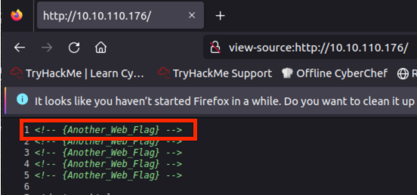

The first thing shown was the seventh flag.

**| {Another_Web_Flag}**

To find the next few webpage flags, I needed to utilize the Linux machine. I executed a simple command to switch user, “*cd /var/www/html*”, and typed in ls to list all the webpage files.

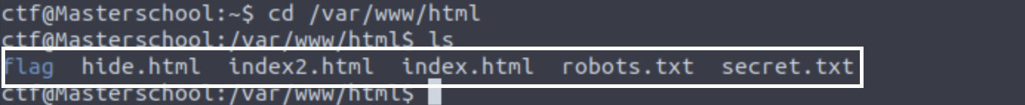

The next steps were self-explanatory, entering these hints with the IP address.

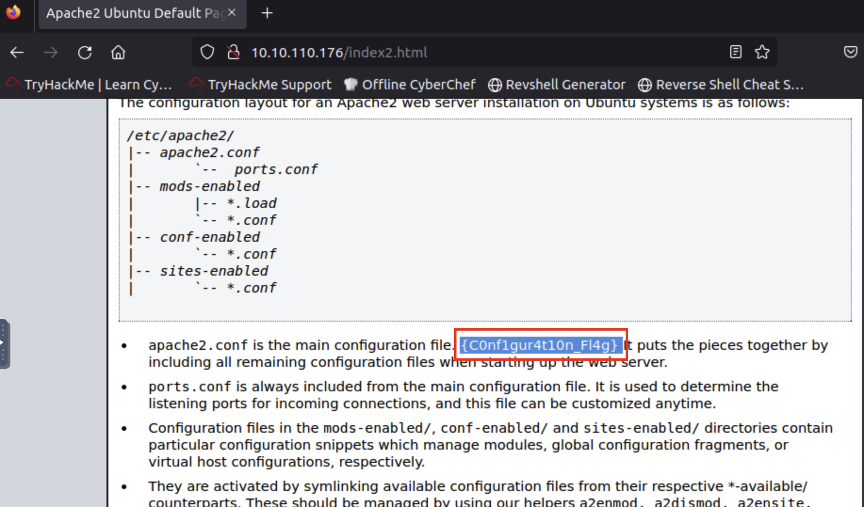

Eighth flag found.

**| {C0nf1gur4t10n_Fl4g}**

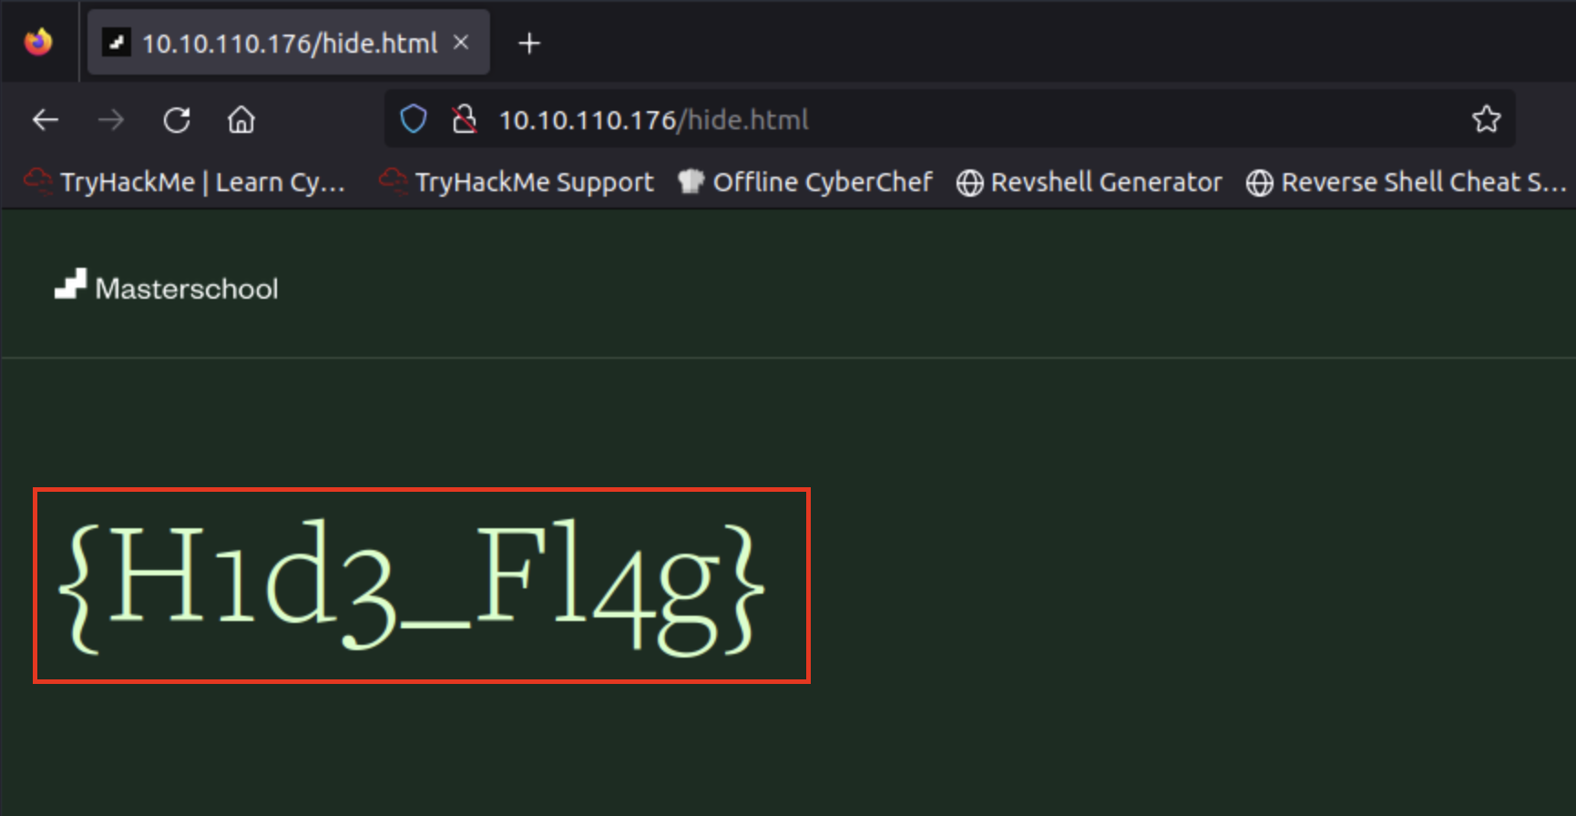

The ninth flag found

**|{H1d3_Fl4g}**

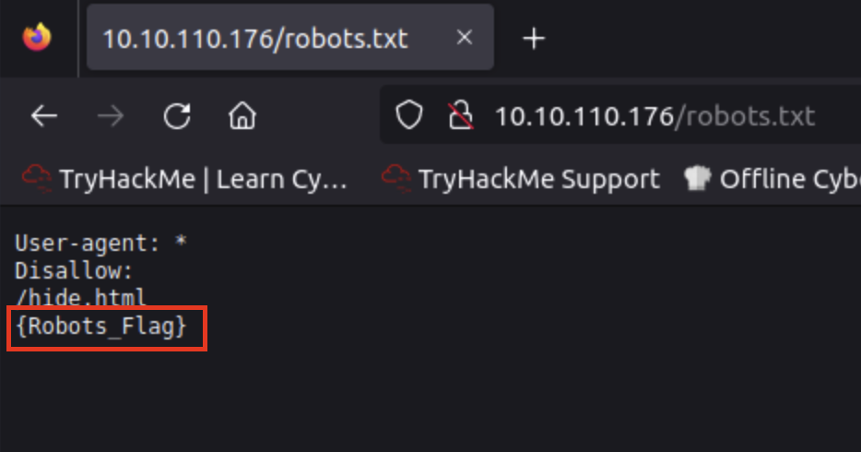

The tenth flag found

**|{Robots_Flag}**

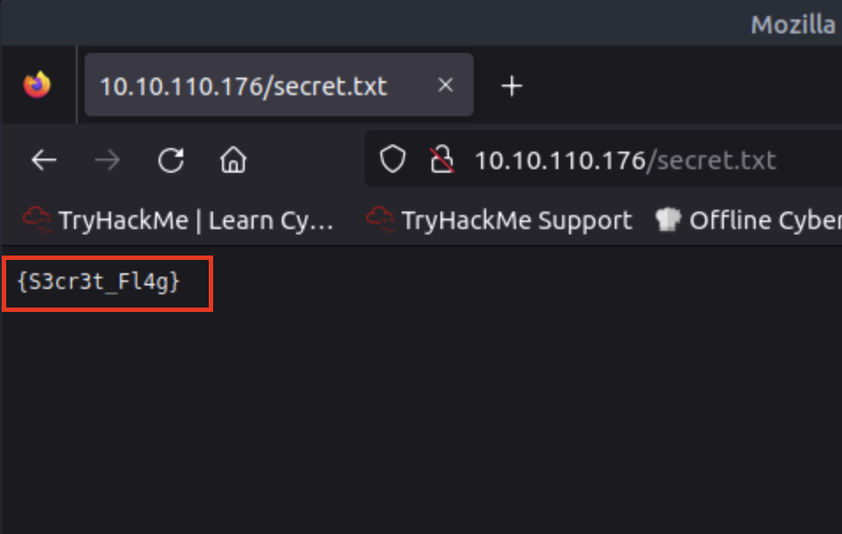

The eleventh flag found.

**|{S3cr3t_Fl4g}**

I utilized Linux to find the last two hidden flags. I executed the same command I used in file system flags: “*find /var -type f -name “*.txt” 2>/dev/null*”.

The hidden flags could be located anywhere, files, network, webpage etc. After executing the command, I found two directories I haven’t used yet which are boxed in white.

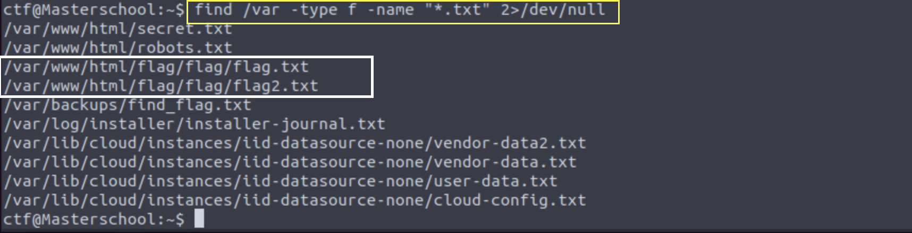

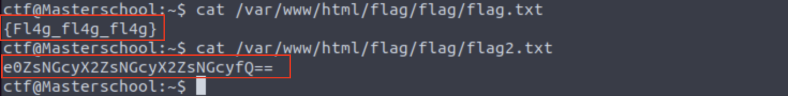

I used the cat command to unveil the hidden flag. Where we found the twelfth flag.

**| {Fl4g_fl4g_fl4g}**

The next flag needed to be decoded, so I needed to use a web source to decode. I used a Base64 format to decode the thirteenth flag.

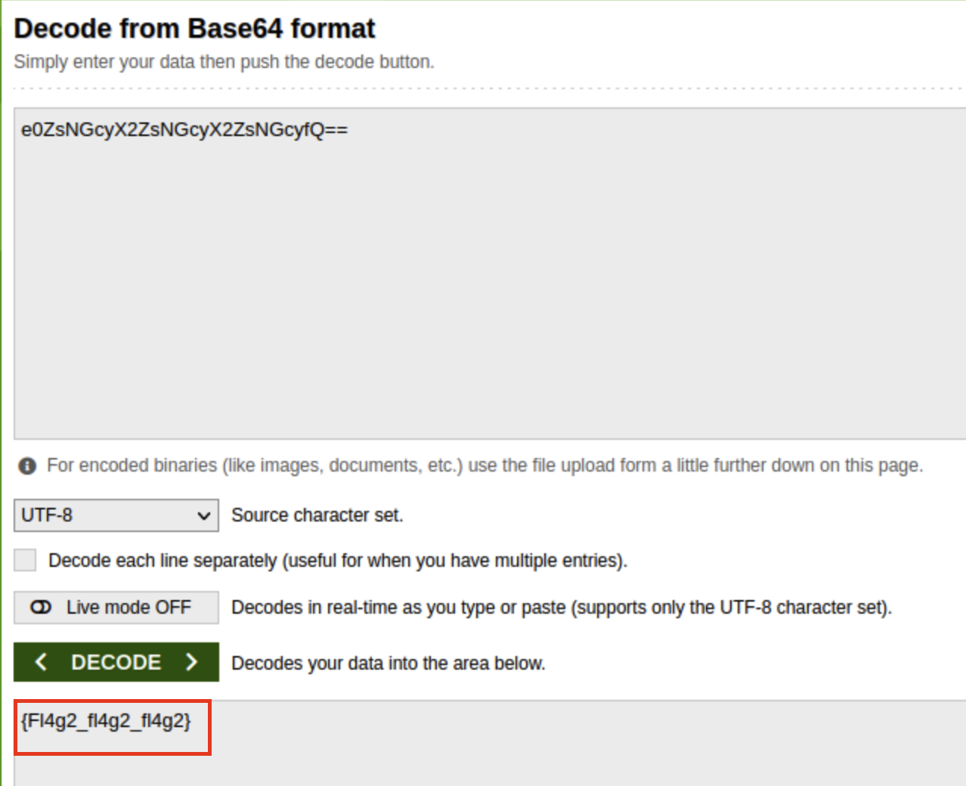

The thirteenth flag found.

**| {Fl4g2_fl4g2_fl4g2}**

**Third and Fourth Challenge done!!**

# Hashing

Hash cracking is part of cryptography which plays a significant role in cybersecurity. This challenge requires the use of tools such as hashcat, john the ripper, hashid, and other websites to decrypt hashes.

For this challenge, the first step was to set up proper tools on the attack machine. I needed to connect to the root server and install hashid and john the ripper which will allow me to identify hashes and hash types. To start the process, I connected to Masterschool CTF server using scp and downloaded **/hash_to_crack** directory which contained several hashes .txt files.

The “SCP” command allows secure transferring of files between local host and the remote host, or between two remote hosts.

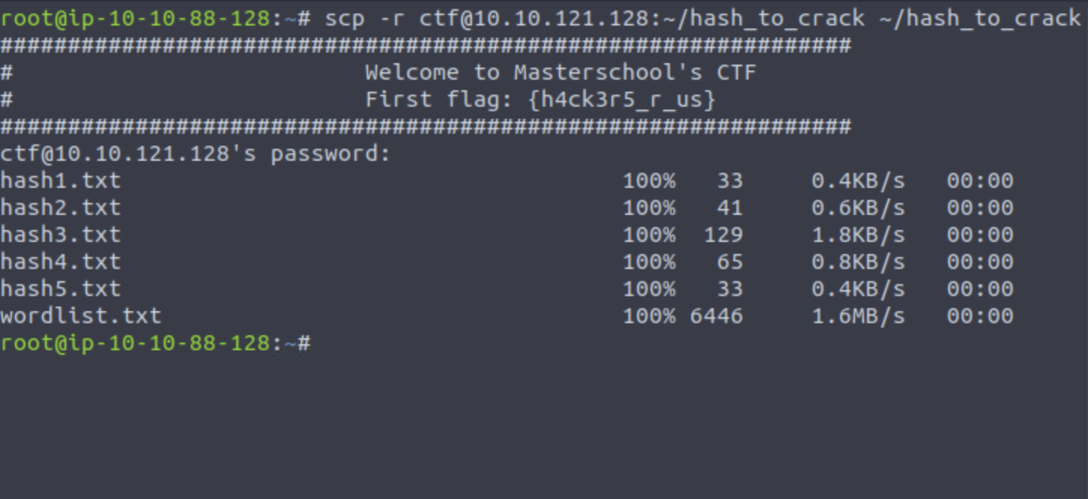

The next step is to download hashid. To do that, I must switch directory to *“/hash_to_crack*” and install hashid.

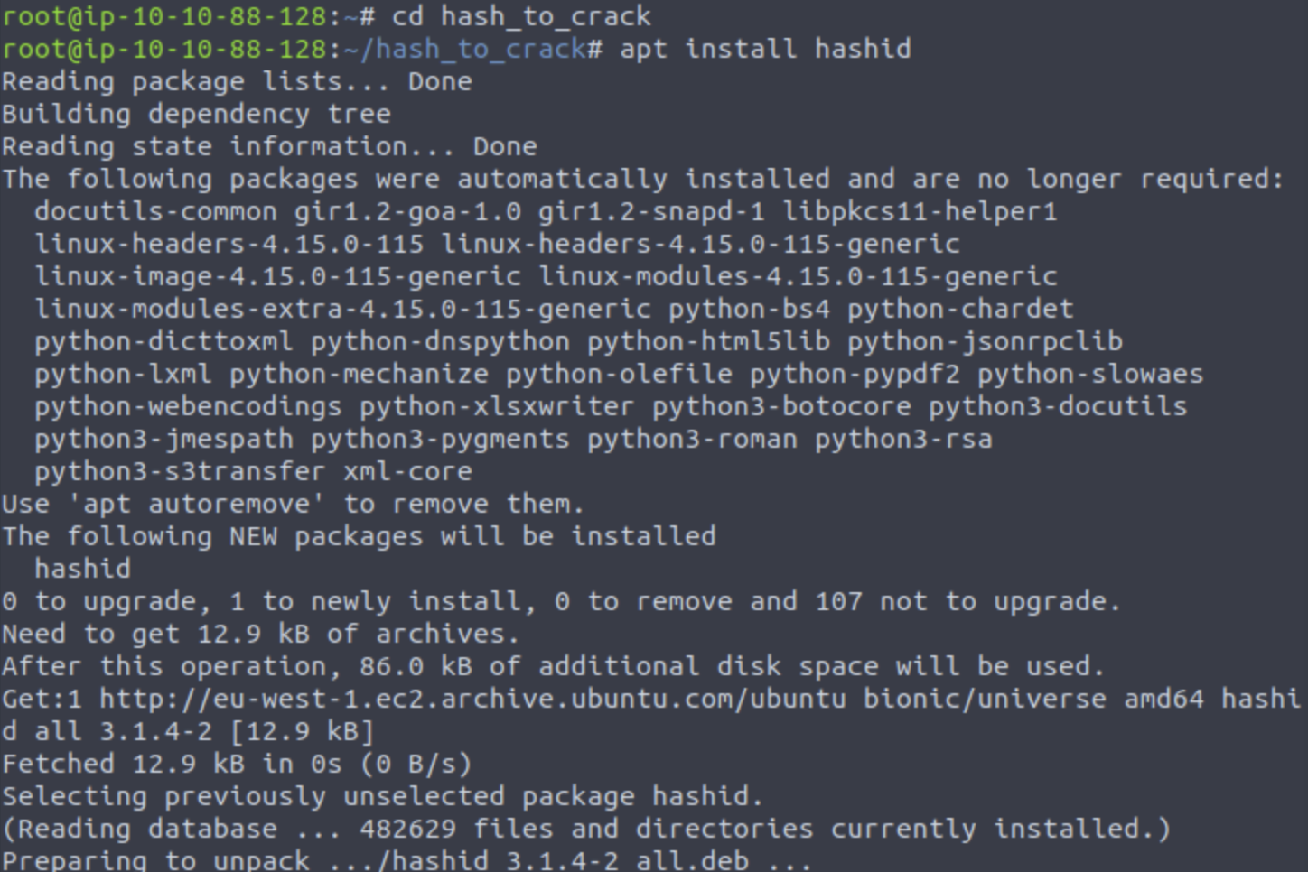

Figure 21: installation of hashid

Now we must install John the Ripper. Same process as we took to install hashid.

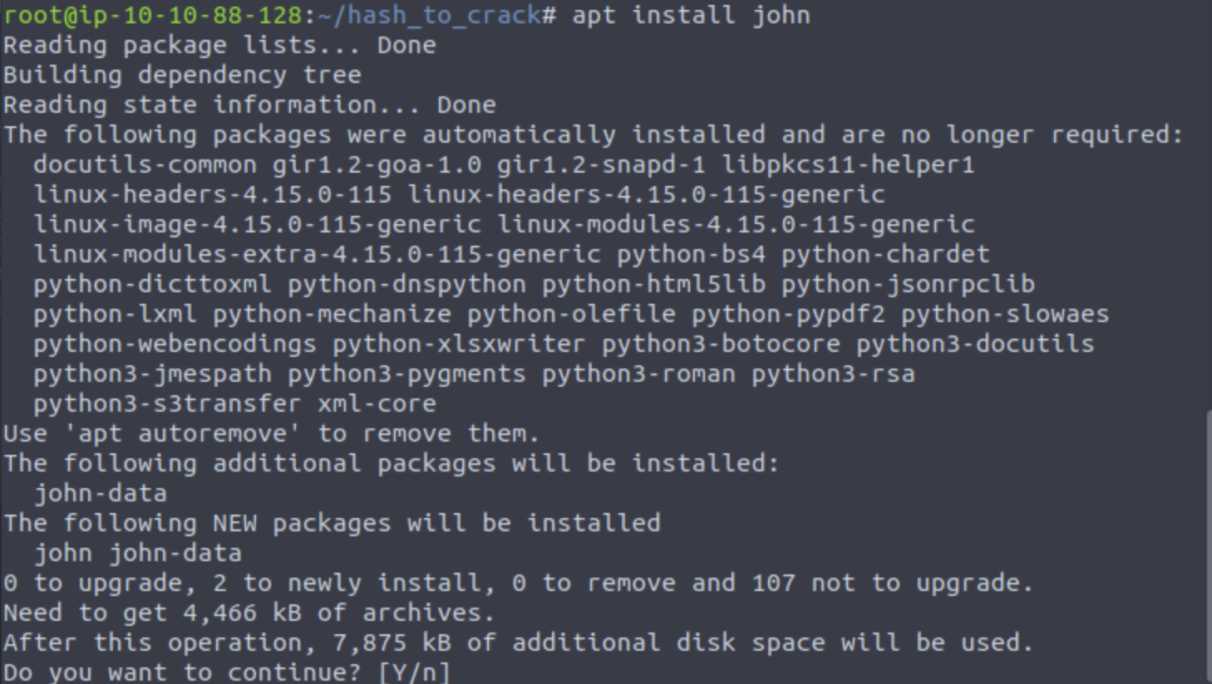

Figure 22: Installation of John The Ripper

Now that we have all the necessary tools, we can start hashing. We have stay in the hash directory to be able to finish this smoothly.

As always, using ls to see the list of files and directories and we can see that there are five hashes. I will be using the cat command unveil the hashes.

In this case, our command is “cat hash1.txt”. which showed a 32-digit hexadecimal numbers.

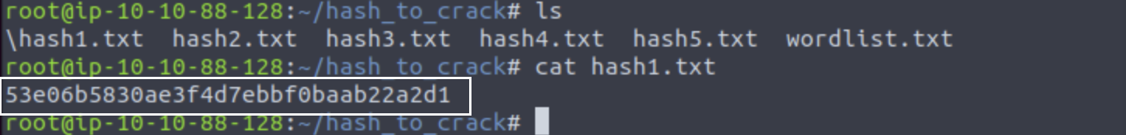

A couple things to keep in mind that, the format of the hash will help us crack the hash. It will tell us which hash algorithm to use to crack the hash. For example, if the hash is MD5, the syntax will contain “*—format=raw-MD5*”. And if its SHA1, it will be formatted as “*—format=raw-SHA!”.* You get the idea.

To identify the format of the hash, I type in hashid and pasted the hash using single or double quotation marks.

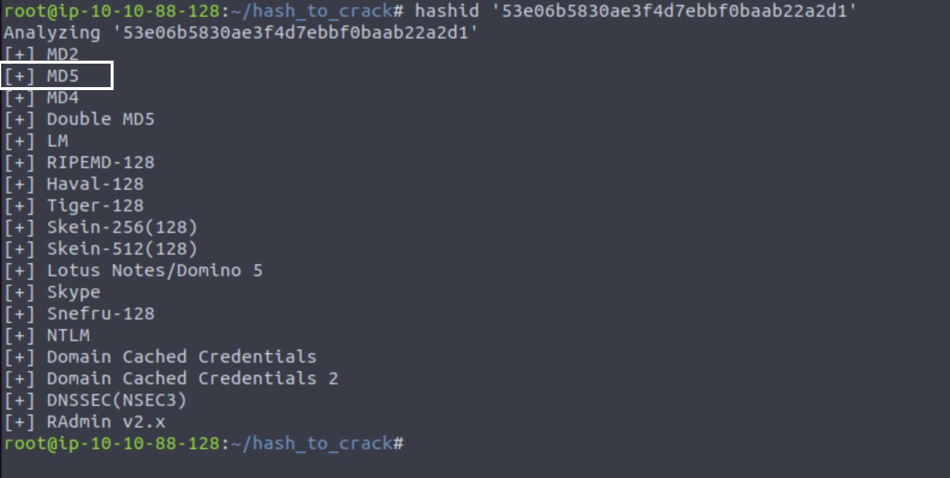

Now that we know what kind of hash algorithm is used, let’s get cracking.

I ran john with –format=raw—MD5 -wordlist=wordlist.txt option.

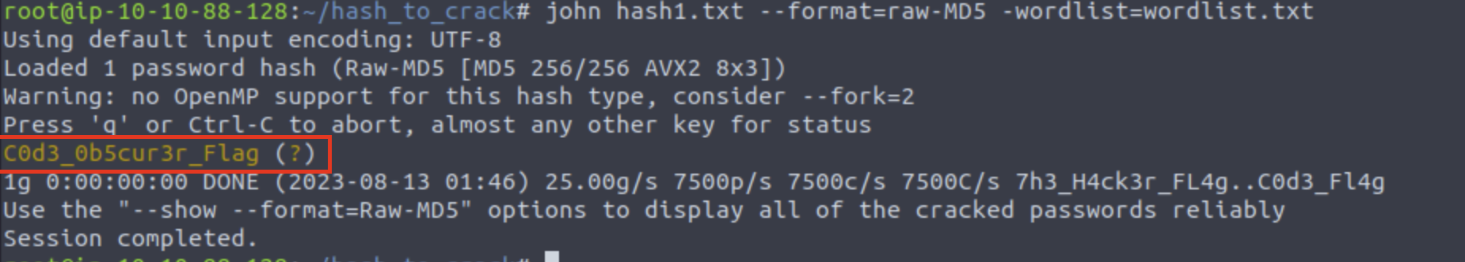

It ran successfully and we have found our first hash and fourteenth flag.

**| C0d3_0b5cur3r_flag**

This methodology will be repeated to crack the remaining hashes.

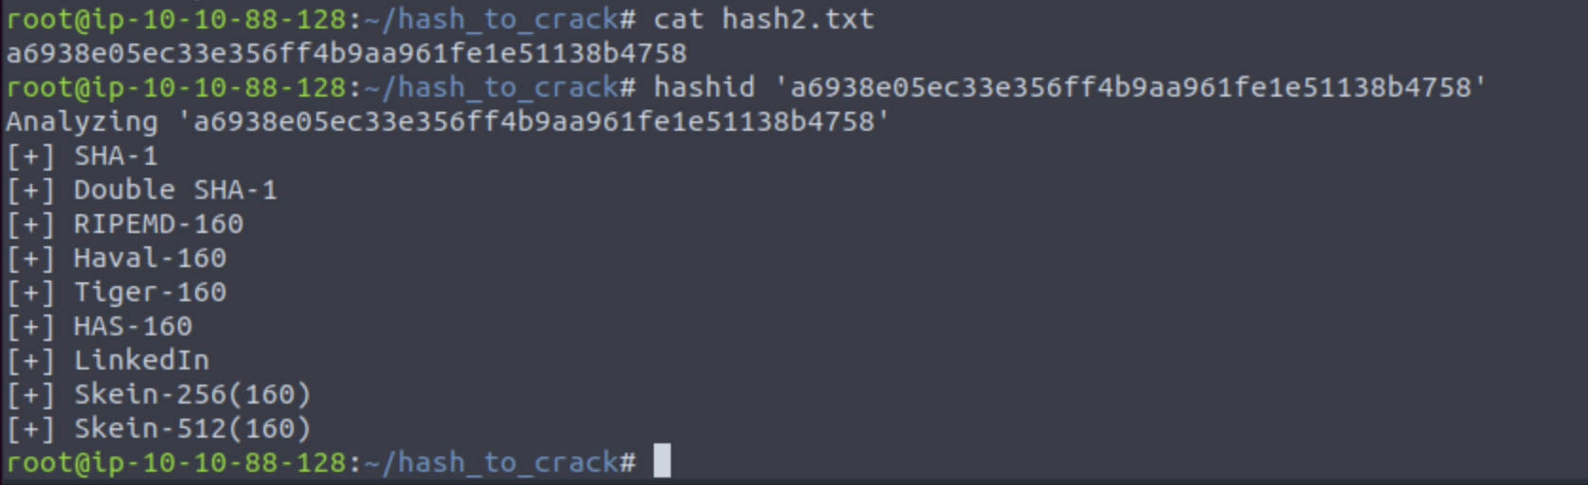

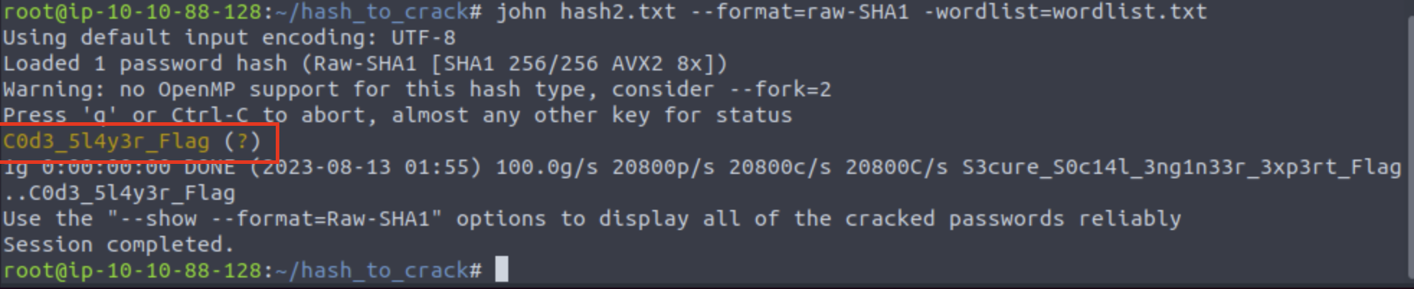

Fifteenth flag found.

**| C0d3_5l4y3r_Flag**

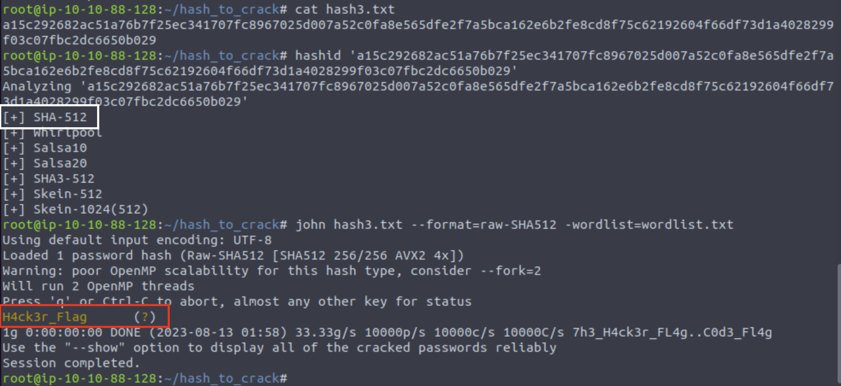

Sixteenth Flag found.

**| H4ck3r_Flag**

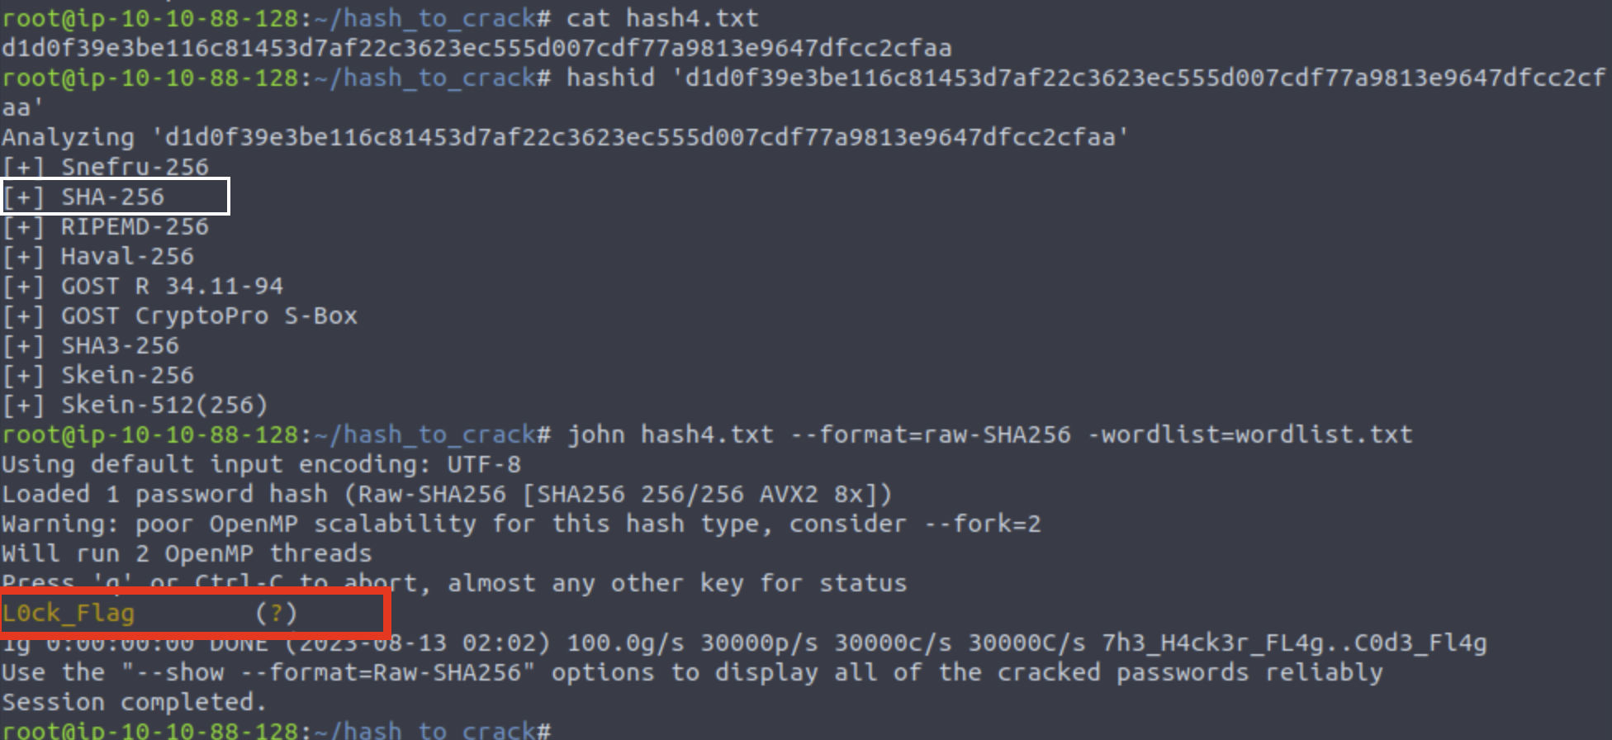

Seventeenth Flag found.

**| L0ck_Flag**

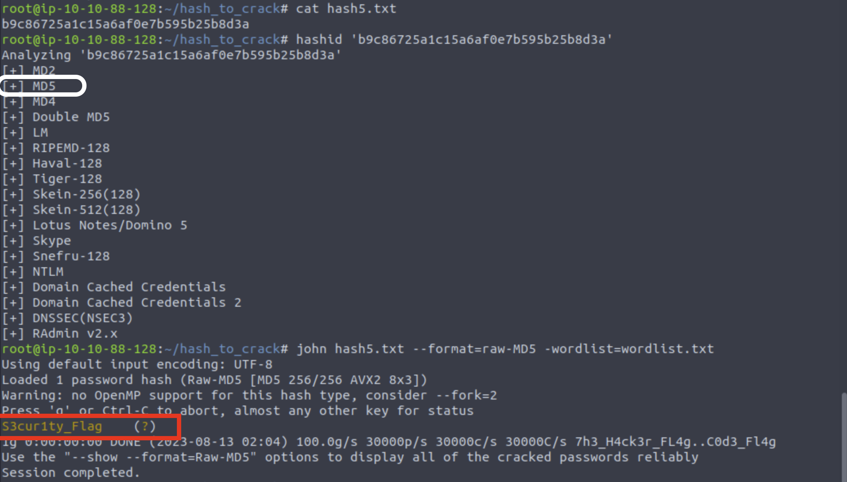

Last hash and our Eighteenth flag found.

**| S3cur1ty_Flag**

**Fifth Challenge Complete!!**

# Nmap Scan Report

Nmap stands for “Network Mapper” which is a free security scanner. It is used for network discovery, host discovery and security auditing. I had to research and utilize chatgpt and google to start the process of Nmap.

The process of nmap allows the evaluation of potential vulnerabilities.

There are a few ways to get in the nmap system. I tried the aggressive (-a) method which was supposedly most useful in some of my peers’ opinions. This was also a very quick and simple way.

To being, I connected to my root server and typed in “nmap -A ‘machine IP Address’ ”.

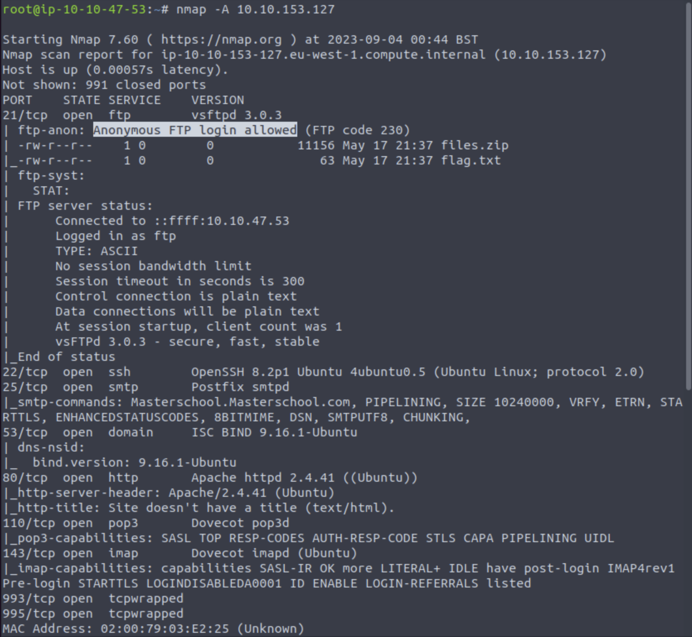

Figure 31: access to namp scan

As soon as it connects, we can see that anonyms log in was allowed for the FTP port.

There are few other ports that are open and accessible such as HTTP. These ports had a huge hand in finding hidden and webpage flags. Since HTTP is open and accessible, I was able to find webpage flags by just entering the IP address of the machine.

Getting into the FTP server was easy. I entered in “*ftp ‘machine IP address’*” which connected me to the machine, I than had to log in anonymously, entered in the password and I was in the system.

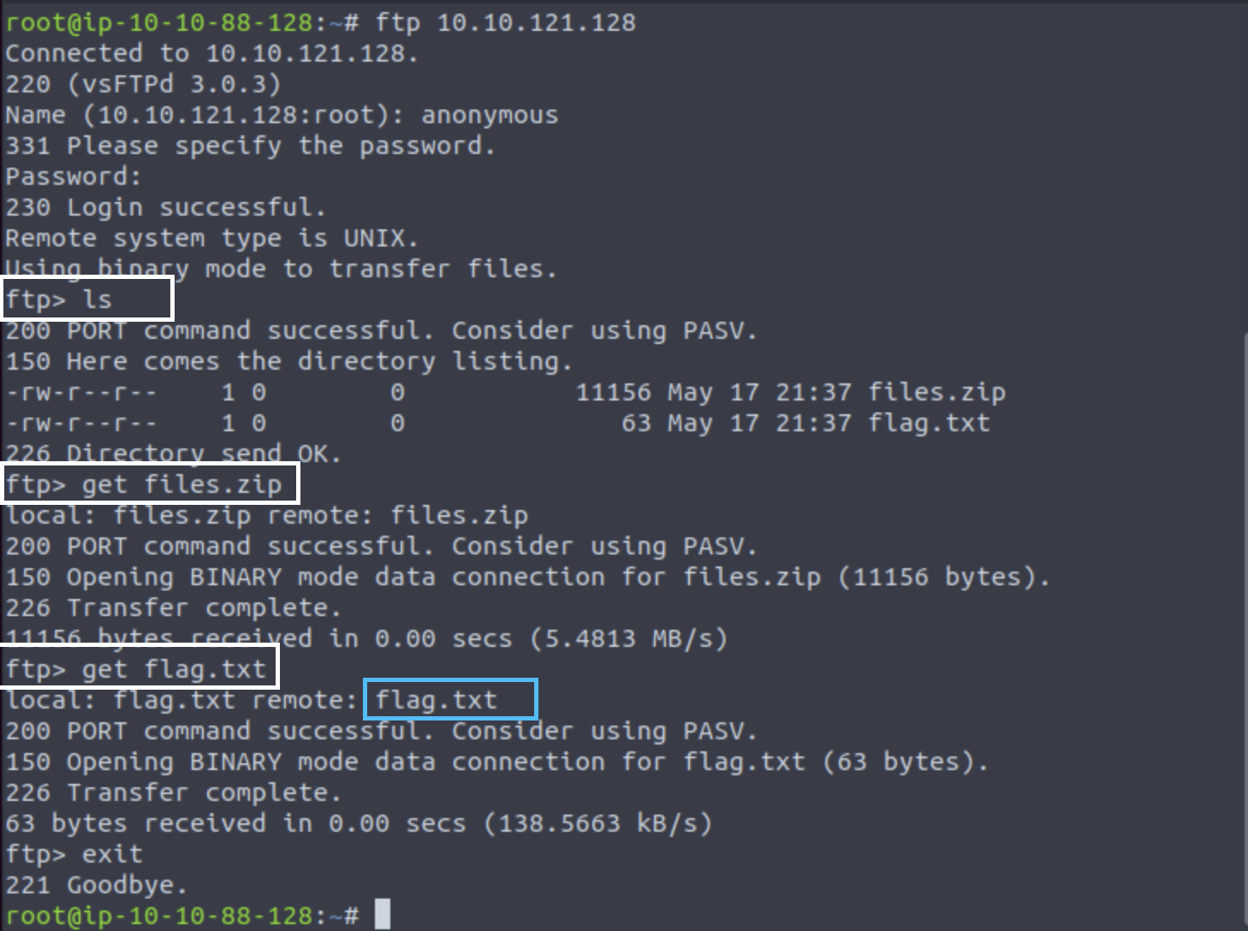

From there, I entered ls to see the list of contents in the FTP directory, which displayed there are two files available for download, **files.zip** and **flag.txt**. The next step is to download these files. To download the files, all I had to type in was “***get files.zip***” and get “***flag.txt***”, as displayed in above figure.

I know that there’s a flag hidden in that FTP server because of the “***flag.txt***”. To find our hidden flag, all I had to do was “**cat flag.txt**” and we found the nineteenth flag.

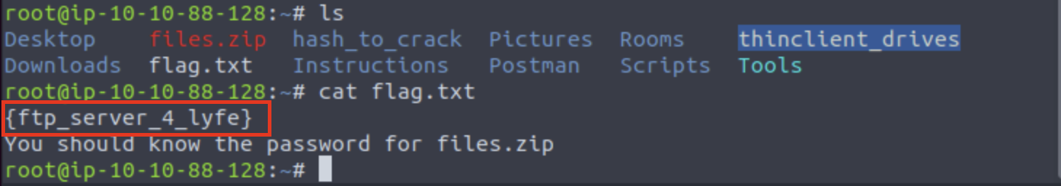

**| {ftp_server_4_lyfe}**

To find the last flag, I will be analyzing the file.zip. The first step is to unzip the file. When I tried to unzip the file, it asked me for a password. Since this CTF was created by Masterschool, I guessed “Masterschool” as the password and now I had access.

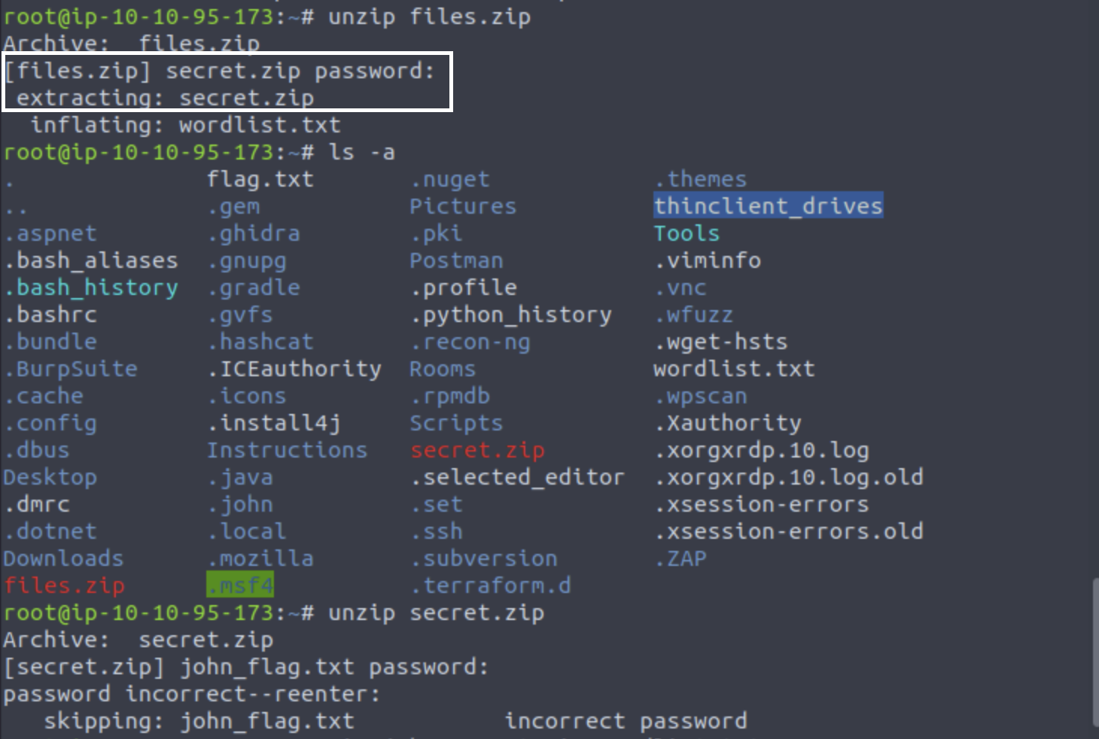

Highlighted in red, there’s a file named “secret.zip”. I knew this is a file I need to get access to as it may contain the last hidden flag. I was unsuccessful when I tired the same password, “masterschool”, so I had to seek aid from my peers. They gave me a hint. They suggested I use zip2john.

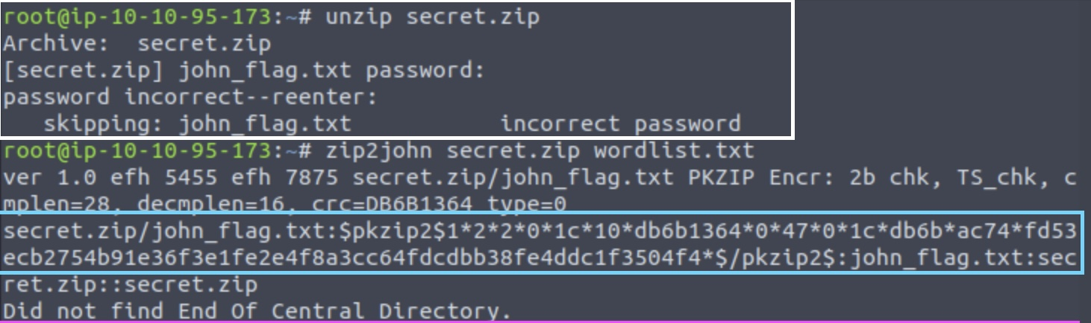

I converted the secret.zip file to “**zip2john secret.zip wordlist.txt**”, as a hash and it gave me a very long hash boxed in blue. I know I can now use John The Ripper to crack the hash and get the password.

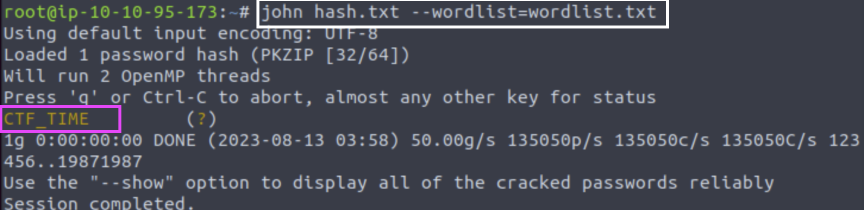

I have been successful, and the password is “CTF_TIME”. Now that I know the password, I can unzip the file.

I can now brute force my way into the file. The command I executed for this was “**unzip -P CTF_TIME secret.zip**” The “-P” option looks for executable files. Another way of doing this was by going back to unzip the file and entering in the password which is “CTF_TIME”. For some reason it gave me extra line of command which I typed “y”.

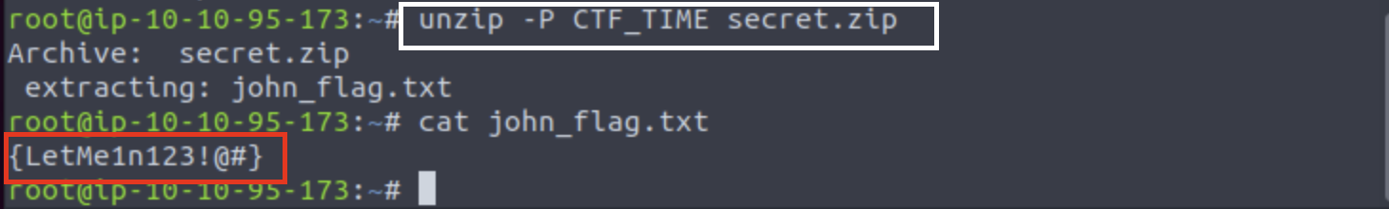

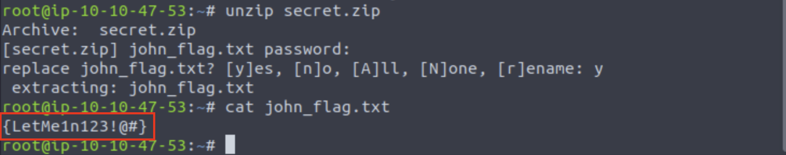

There we have it, the last flag. Twentieth flag found.

**| {LetMe1n123!@#}**

After completing this nmap scan, it is clear the server needs stronger security. I was able to get access to vulnerable files easily. Here are some things I noticed:

Unauthorized access was allowed on FTP port 21, which is a risk as anyone can download and get access to the files. This can be avoided by disabling unauthorized log in’s and put an extra layer of security such as “security questions”.

There were plain text protocols such as FTP, POP3 and SMPT, which means traffic was sent through these protocols uncrypted making it more vulnerable for theft and fraud. One way to avoid this is by allowing a version of SSL or TLS of FTP, SMTP, IMAP etc.

It is crucial to have secure and protected data. Few ways this can be done is by:

1. Encrypting the connection.
2. Defending user accounts and permissions
3. Enforcing password compliance
4. Detecting and responding to password attack.
   1. Number of times a password can be incorrect.
5. Enabling time and IP limits.

Conclusion

The process of finding the flags was a bit challenging. There were times when I was unable to come up with a solution, so I sought aid from peers and AI. Which is encouraged as a cybersecurity professional.

The challenge allowed me to think outside the box and practice my communication with online aid, and my attention to detail as flags were hidden anywhere and everywhere. The most challenging part about this practice was the nmap scan, finding the last hidden flag. I was unsure how to unzip the file. Unzipping secret.zip gave me the name of the file but I was unsuccessful with guessing the password. After asking my peers, I was able to figure out I had to hash the file and find the password by using john the ripper. This process took me about a couple hours.

The best and the easiest part about this challenge was the hashing. It was quite simple, and I had so much fun cracking the hashes. There were five hashes, and the same steps were taken to crack the hash. The only challenge I faced during this part of the challenge was copying and pasting the hash into “hashid”. I figured it out in the end.

Overall, this challenge gave me a lot of insights on security, encryption, SSL protocols and much more. If I were to do this challenge again, I will be able to complete it without much struggle.

This challenge has also proven the skills I am learning at masterschools will continue to enlighten my knowledge of cybersecurity.

## Appendix

TryhackMe

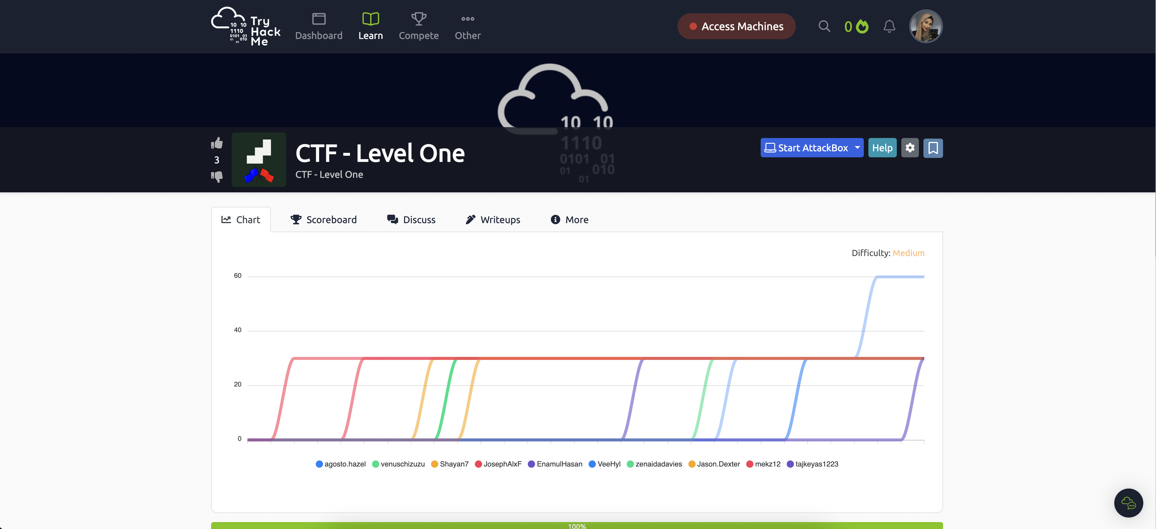

ChatGPT – for proper command lines and syntax to use.



AttackBox (Virtual Machine)

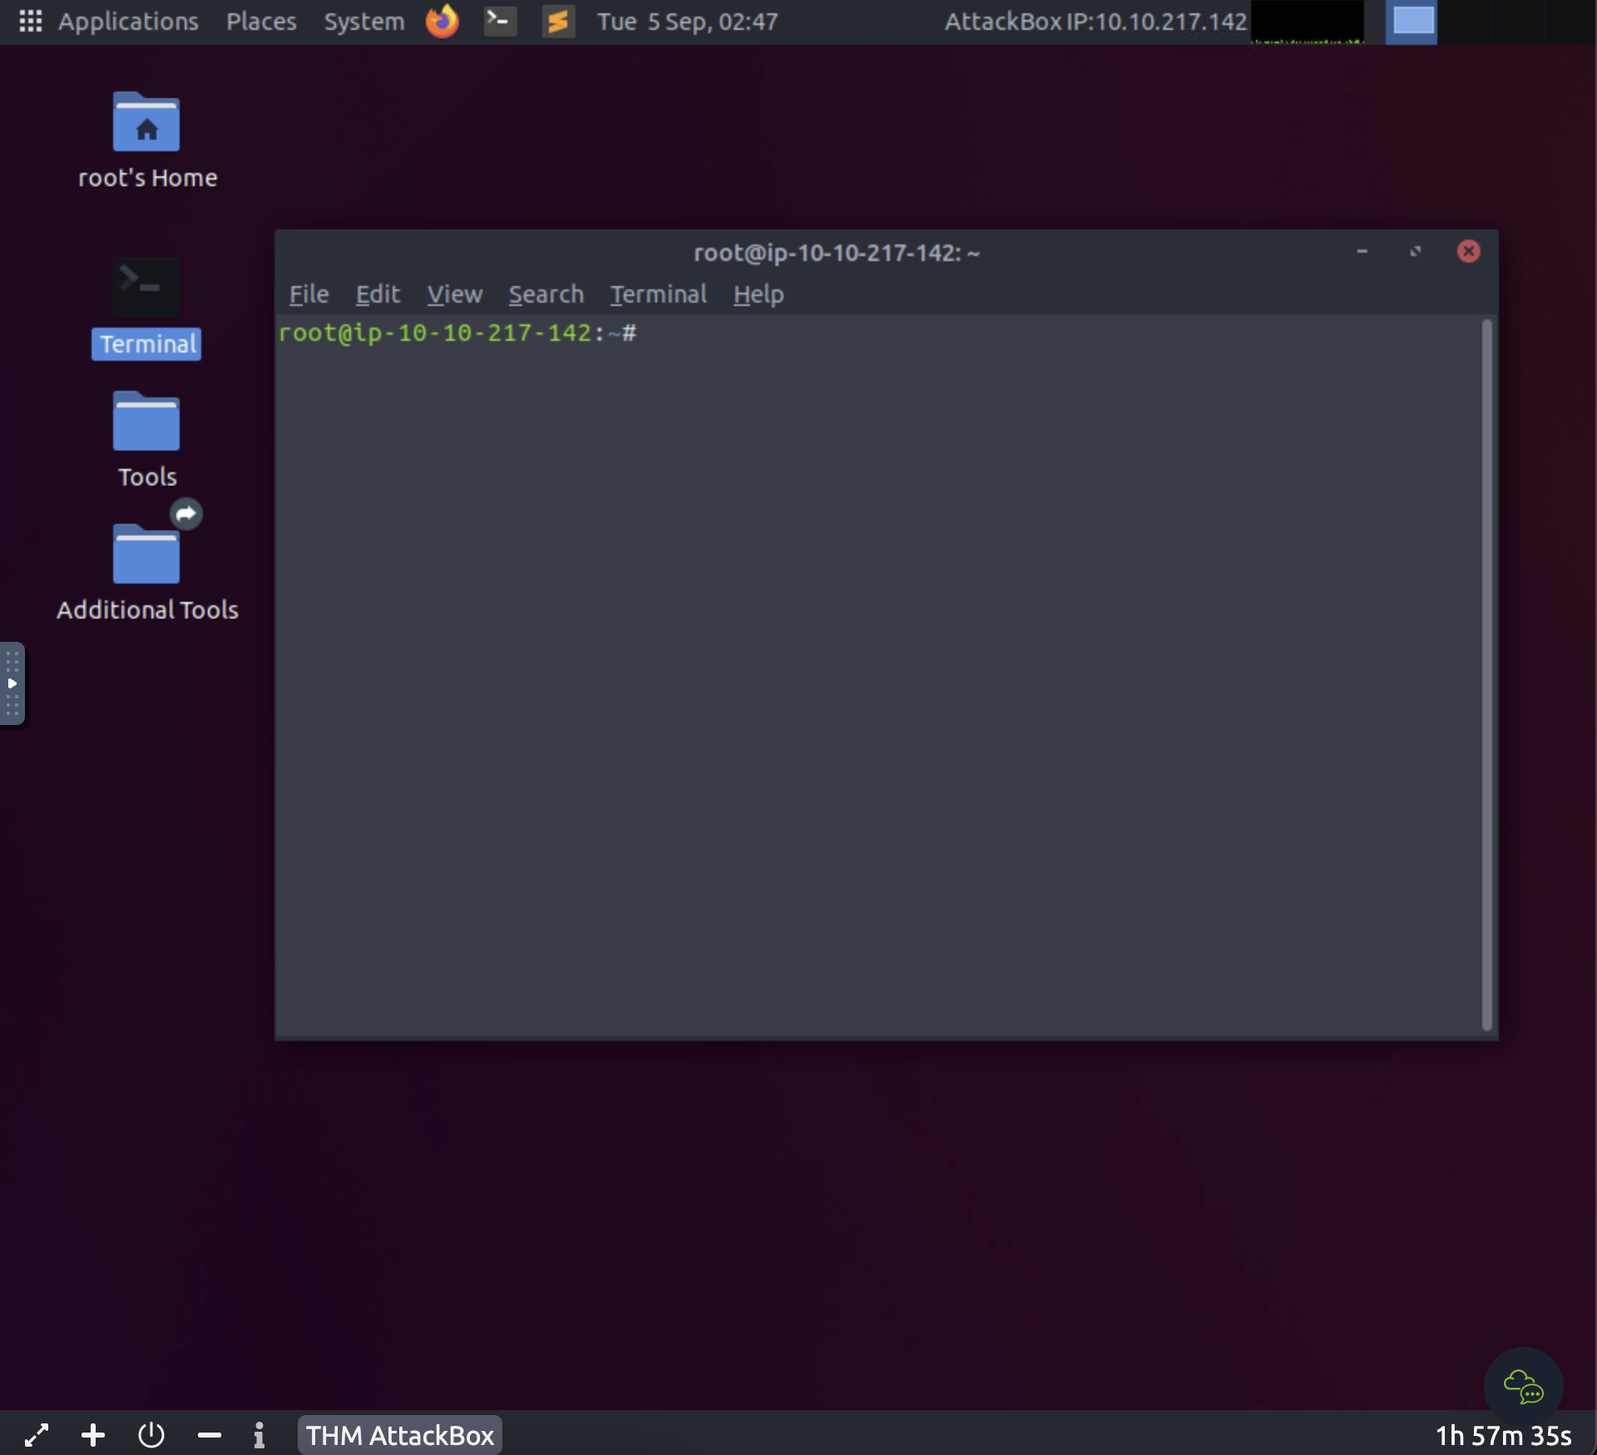

VM Firefox Web browser – Used when finding webpage flags

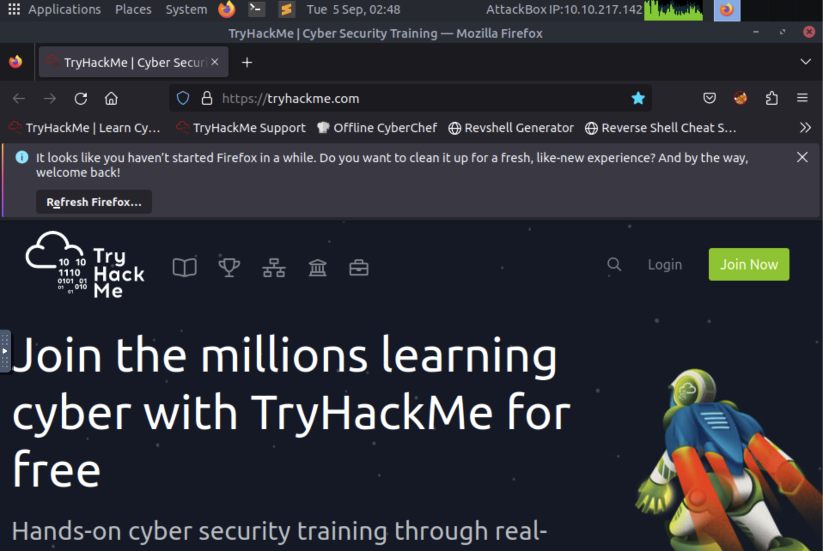

Tools used to decode:

Hashcat

John The Ripper

HashID